**Patent Developer Code Environment Setup**



Imboden, Tom (RT-PHL)

This page provides software installation instructions to begin working on Patent web applications. These instructions include installation and configuration for Visual Studio, TFS, Node.js, and Angular.

**Contents**

* [Visual Studio Code Installation](https://tfsprod.reedtech.com/tfs/ReedTech/ReedTech/_wiki/wikis/ReedTech.wiki/153/Patent-Developer-Code-Environment-Setup#visual-studio-code-installation)
* [VS and DevOps Server Setup](https://tfsprod.reedtech.com/tfs/ReedTech/ReedTech/_wiki/wikis/ReedTech.wiki/153/Patent-Developer-Code-Environment-Setup#vs-and-devops-server-setup)
  + [NOTE: We are moving away from TFS to using Git instead. Follow the Git wiki articles for that.](https://tfsprod.reedtech.com/tfs/ReedTech/ReedTech/_wiki/wikis/ReedTech.wiki/153/Patent-Developer-Code-Environment-Setup#note%3A--we-are-moving-away-from-tfs-to-using-git-instead.--%5Bfollow-the-git-wiki-articles-for-that%5D(https%3A%2F%2Ftfsprod.reedtech.com%2Ftfs%2Freedtech%2Freedtech%2F_wiki%2Fwikis%2Freedtech.wiki%2F230%2Fgit).)
* [Angular and Node.js Installation](https://tfsprod.reedtech.com/tfs/ReedTech/ReedTech/_wiki/wikis/ReedTech.wiki/153/Patent-Developer-Code-Environment-Setup#angular-and-node.js-installation)
* [Adobe Acrobat DC (if project needs it)](https://tfsprod.reedtech.com/tfs/ReedTech/ReedTech/_wiki/wikis/ReedTech.wiki/153/Patent-Developer-Code-Environment-Setup#adobe-acrobat-dc-(if-project-needs-it))
* [Database Environment Setup](https://tfsprod.reedtech.com/tfs/ReedTech/ReedTech/_wiki/wikis/ReedTech.wiki/153/Patent-Developer-Code-Environment-Setup#database-environment-setup)
* [Sharing Local Folder for Network Access to "C:\IDMS"](https://tfsprod.reedtech.com/tfs/ReedTech/ReedTech/_wiki/wikis/ReedTech.wiki/153/Patent-Developer-Code-Environment-Setup#sharing-local-folder-for-network-access-to-%22c%3A%5Cidms%22)
* [Enable SMB 1.0 Windows feature](https://tfsprod.reedtech.com/tfs/ReedTech/ReedTech/_wiki/wikis/ReedTech.wiki/153/Patent-Developer-Code-Environment-Setup#enable-smb-1.0-windows-feature)
* [Atalasoft - DotImage](https://tfsprod.reedtech.com/tfs/ReedTech/ReedTech/_wiki/wikis/ReedTech.wiki/153/Patent-Developer-Code-Environment-Setup#atalasoft---dotimage)

**Visual Studio Code Installation**

For general development software installation instructions, refer to this link – [New Developer Setup](https://tfsprod.reedtech.com/tfs/ReedTech/ReedTech/_wiki/wikis/ReedTech.wiki?wikiVersion=GBwikiMaster&pagePath=%2FReed%20Tech%20Developer%20Wiki%2FLife%20Sciences%20Team%20Wikis%2FNew%20Developer%20Setup).

After installing Visual Studio Code, install the latest versions of the following Extensions:

* "Angular Essentials" by John Papa
* "TFS" by Ivan Gabriele **
* "angular2-inline" by Nate Wallace
* "TSLint" by Microsoft
* "Path Intellisense" by Christian Kohler
* "npm Intellisense" by Christian Kohler

** The "TFS" extension may need to be configured manually:

1. Close VS Code
2. In file explorer, go to %USERPROFILE%\.vscode\extensions\ivangabriele.vscode-tfs-0.7.2\node_modules\tfs\config (or whatever the version number folder is)
3. Open the "settings.json" file in an editor
4. Make sure it contains the following, changing the version and/or folder path of Visual Studio as appropriate:

{

"tfPath": "C:\\Program Files (x86)/Microsoft Visual Studio/2019/Professional/Common7/IDE/CommonExtensions/Microsoft/TeamFoundation/Team Explorer/TF.exe",

"vsArchitecture": 32,

"vsVersion": 2019

}

1. Save and close the file

**VS and DevOps Server Setup**

1. Make sure that Outlook is configured to receive external emails. If Outlook is not configured to receive external emails, submit a helpdesk ticket at the link below.  
   [https://reedtech.cherwellondemand.com](https://reedtech.cherwellondemand.com/)
2. Make sure Visual Studio (VS) 2019 Professional is installed from MS [Here](https://visualstudio.microsoft.com/downloads/) and log in using your legal account.
3. In Team Explorer, click Manage Connections > Add Azure DevOps Server and enter "[http://tfsprod.reedtech.com](http://tfsprod.reedtech.com/) ".
4. Select $/ReedTech and click "Connect".

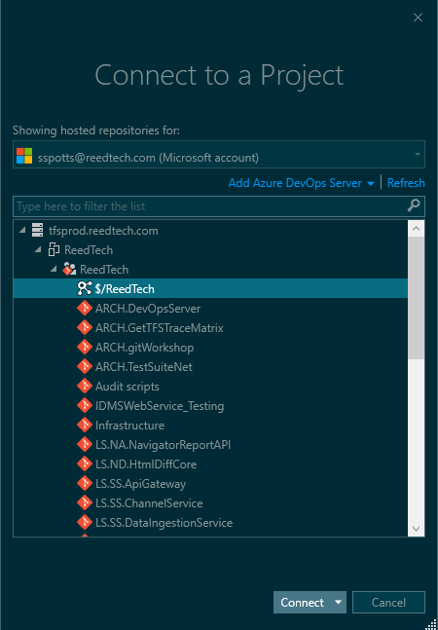

1. Open Source Control Explorer and click "Not mapped".

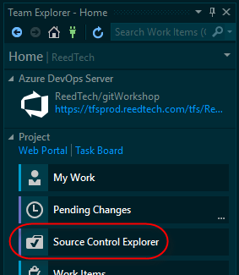

1. Specify the local folder path as "C:\ReedTech" and click "Map". The mapped path must be "C:\ReedTech" in order for everything to work properly.

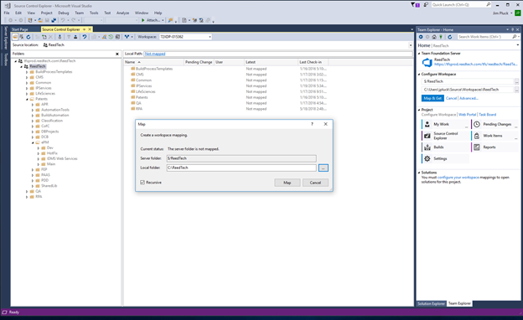

1. Right click the projects you want to download and select "Get Latest".
2. You may have to restart Visual Studio after these steps.
3. Back in Visual Studio, Select the Tools drop down menu and select Options.
4. Locate the NuGet Package Manager > Package Sources option.
5. Create a new package source by pressing the green plus (+) symbol.
6. Enter in Name: "RTIS".
7. Enter in Source: <https://tfsprod.reedtech.com/tfs/reedtech/_packaging/ReedTech/nuget/v3/index.json>
8. Click update. Make sure the checkbox is checked and move the row to the top by selecting the up arrow.

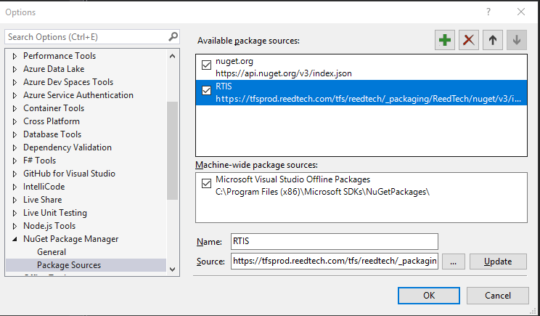

1. Set up your personal branch by following the instructions in [TFVC Personal Branches](https://tfsprod.reedtech.com/tfs/ReedTech/ReedTech/_wiki/wikis/ReedTech.wiki?wikiVersion=GBwikiMaster&pagePath=%2FReed%20Tech%20Developer%20Wiki%2FPatent%20Team%20Wikis%2FSoftware%2FTFVC%20Personal%20Branches).

**NOTE: We are moving away from TFS to using Git instead.**[**Follow the Git wiki articles for that**](https://tfsprod.reedtech.com/tfs/reedtech/ReedTech/_wiki/wikis/ReedTech.wiki/230/git)**.**

**Angular and Node.js Installation**

See [Angular and Node.js Setup](https://tfsprod.reedtech.com/tfs/ReedTech/ReedTech/_wiki/wikis/ReedTech.wiki?wikiVersion=GBwikiMaster&pagePath=%2FReed%20Tech%20Developer%20Wiki%2FPatent%20Team%20Wikis%2FSoftware%2FAngular%20and%20Node.js%20Setup)

**Adobe Acrobat DC (if project needs it)**

1. Install AcrobatDCEnterprise from the Software Center

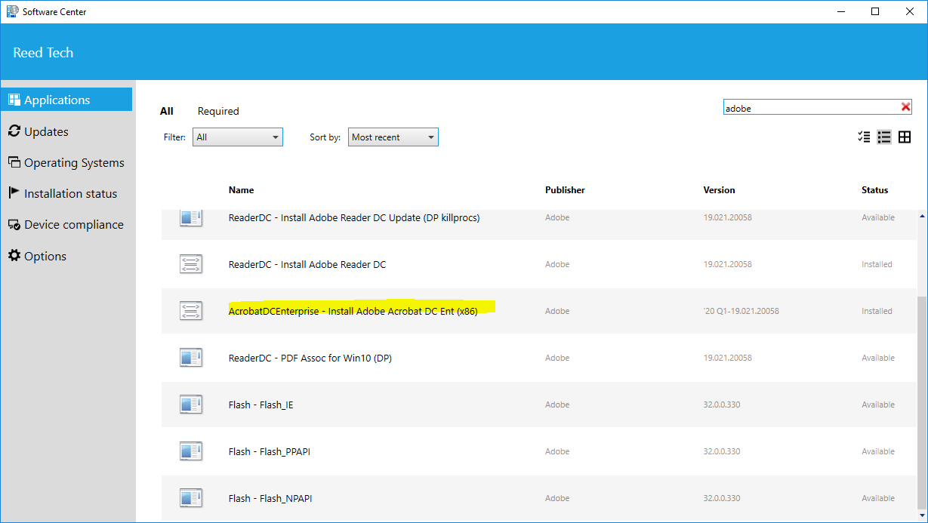

1. Go to <https://www.adobe.com/>  and sign up for a new account with your @reedtech.com e-mail address.
2. Put in ticket with the Reed Tech help desk asking for an "Adobe Pro license". Let the help desk technician know the name of your manager so they can double check for approval, also let them know that you have created an Adobe account with your @reedtech e-mail: <https://reedtech.cherwellondemand.com/CherwellClient/Access/Locale-en-US>
3. When you hear back from help desk, run Adobe Acrobat DC. Enter in your [adobe.com](http://adobe.com/)  credentials. At this point you should be all set.

**Database Environment Setup**

For patent team DB environment setup, refer to this link – [Patent Developer DB Environment Setup](https://tfsprod.reedtech.com/tfs/ReedTech/ReedTech/_wiki/wikis/ReedTech.wiki?wikiVersion=GBwikiMaster&pagePath=%2FReed%20Tech%20Developer%20Wiki%2FPatent%20Team%20Wikis%2FSoftware%2FPatent%20Developer%20DB%20Environment%20Setup).

**Sharing Local Folder for Network Access to "C:\IDMS"**

For working with ePM system software, we enable access from remote web servers to local machines via sharing the C:\IDMS folder.

For ePM, create a folder named "IDMS" on your C:\ drive. Right-click on th folder and go to "Properties". On the Properties dialog, go to the Sharing" tab. Click the "Share" button:

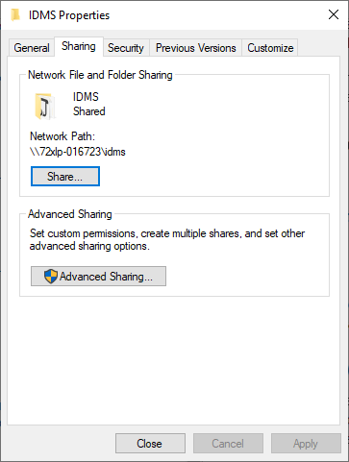

Make sure to add the "eProdLocal" group with permission level "Contribute"

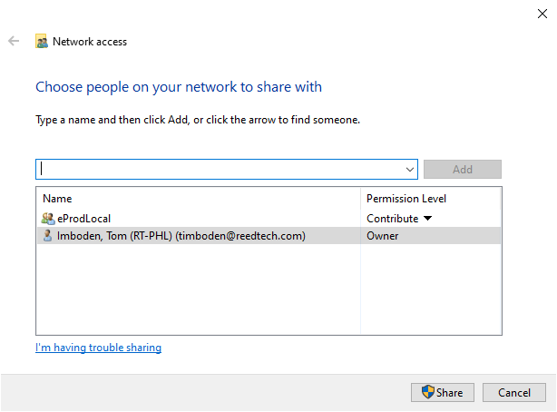

Click the "Share" button to allow sharing access.

From the Properties > Sharing tab again, click Advanced Sharing and make sure "Share this folder" is checked and the Share name is "IDMS":

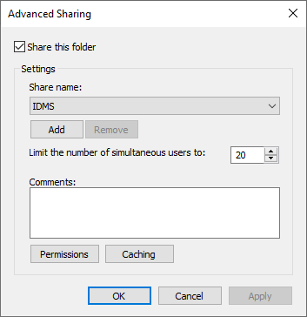

**Note for FEP development:**  
The folder is C:\FEP_SHARE, "Everyone" group is given Read/Write permission, and the share name is "FEP_SHARE".

**Enable SMB 1.0 Windows feature**

SMB is used to write files to the local disk (C:\IDMS). In control panel go to "Programs and Features" widget. Click on "Turn Windows Features on or off". Make sure "SMB 1.0/CIFS File Sharing Support" is installed. On Windows 10 1803+ there are multiple options. Just make sure both client and server are installed.

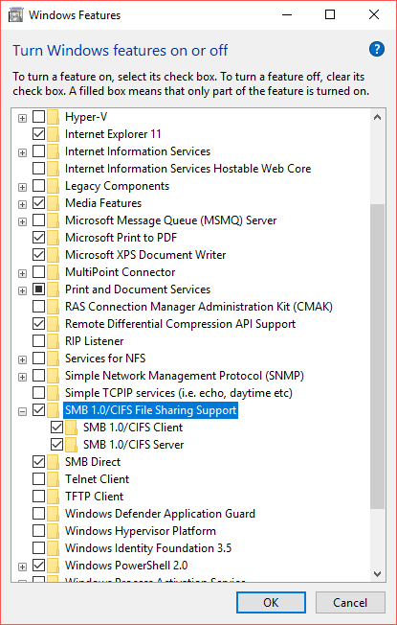

Refer to [File-Sharing-and-SMB](https://tfsprod.reedtech.com/tfs/ReedTech/ReedTech/_wiki/wikis/ReedTech.wiki?wikiVersion=GBwikiMaster&pagePath=%2FReed%20Tech%20Developer%20Wiki%2FTechnology%20Wikis%2FFile%20Sharing%20and%20SMB) topic for more information on this feature.

**Atalasoft - DotImage**

Some applications, like eTable and Image Prep, require a valid license(s) from Atalasoft to work correctly during development. Otherwise, you might see an "AtalasoftLicenseException" like this:

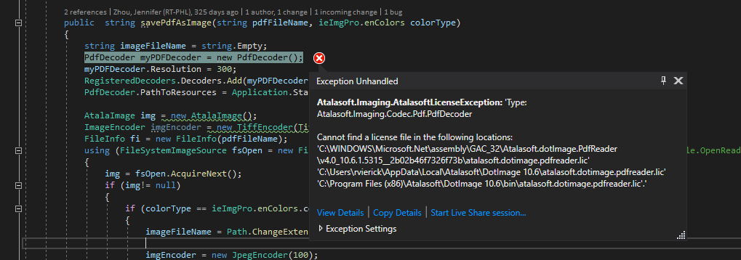

If you're working on an application that requires a valid Atalasoft license first get approval from your manager. After being approved and getting a valid license key, you'll need to create an Atalasoft account (using your work e-mail address) here: <https://www.atalasoft.com/Home> .

The version of DotImage (PDFReader should also be included in this SDK, it just has a separate license) that you need is probably going to be found in this folder here, however this may vary from application to application and/or license to license: \\reedtech.com\Tech\Dev_RND\qa_test\TOOLS\Atalasoft\10.6.1.7 - FixPack.

Follow the install instructions. To activate the license, choose "Activate an SDK serial number for use on this machine, or a server license" and add the license key you got from you manager on the next page.

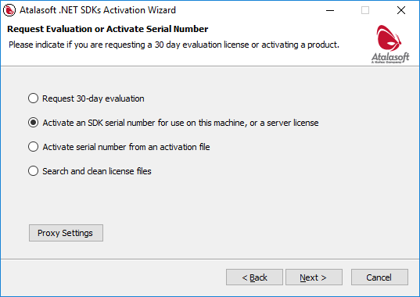

**Be sure that the "License Version" selected matches the software you have installed/the license you received.**

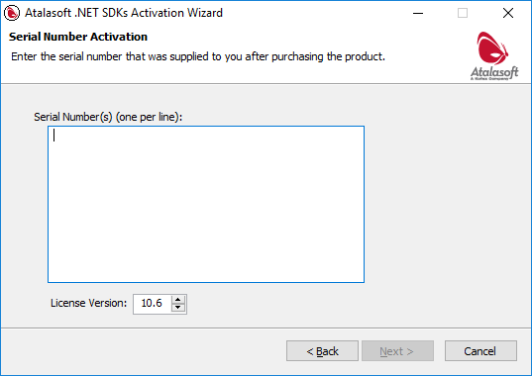

After that you should be all set.

If the activation didn't work and it could only create an offline configuration file, you can activate that offline file by going to this webpage and following the instructions: <https://www.atalasoft.com/Support/My-Portal/Activate-Serial>

The 10.7 license is backwards compatible with 10.6, so you can make this directory: C:\Users\{user-name}\AppData\Local\Atalasoft\DotImage 10.6 given that your application is using 10.6 instead of 10.7.

However, not all licenses are backwards compatible and it is recommended that you use the setup wizard associated with your target version.

If you need to add additional licenses to your machine after installing, just use the "DotImageActivationWizard.exe" found in Program Files for your particular version. As an example: "C:\Program Files (x86)\Atalasoft\DotImage 10.6\DotImageActivationWizard.exe"

If you want to see all of your existing license files, they are likely in this location: "%localappdata%\Atalasoft\DotImage {MajorVersionNumber}.{MinorVersionNumber}". Here's an example: %localappdata%\Atalasoft\DotImage 10.6. If the license file contains an <Expiration> node it means that it is a trial version. License files can technically exist in other places on disk so if you are having license issues it may be necessary to search the whole disk for "Atalasoft.*.lic" files.

Here's an image of what this folder looks like with licenses installed for both dotImage and PDFReader:

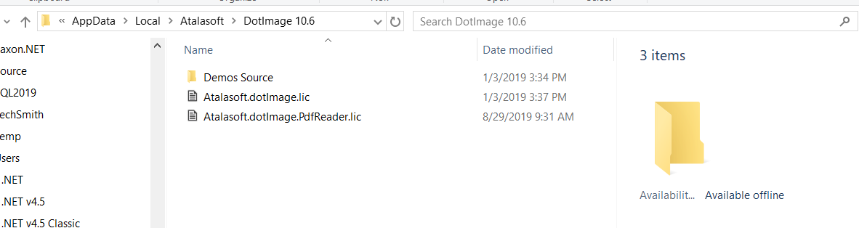

*Note: The assigned licenses for DotImage and PDFReader are available on this spreadsheet here: \\reedtech.com\Tech\Dev_RND\qa_test\TOOLS\Atalasoft\Atalasoft_SDK_licenses.xlsx.*